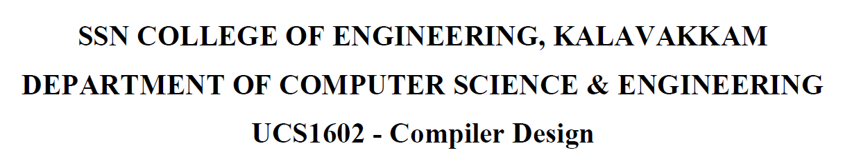

**UCS1712-Graphics and Multimedia Lab**

**Programming Assignment 3**

**Bresenham’s Line Drawing Algorithm in C++ using OpenGL**

Name: Jayannthan P T

Dept: CSE ‘A’

Roll No.: 205001049

To plot points that make up the line with endpoints (x0,y0) and (xn,yn) using Bresenham’s line drawing

algorithm.

Case 1: +ve slope Left to Right line

Case 2: +ve slope Right to Left line

Case 3: -ve slope Left to Right line

Case 4: -ve slope Right to Left line

Each case has two subdivisions

(i) |m|<= 1 (ii) |m|>1

Note that all four cases of line drawing must be given as test cases.

**Source code:**

#include <iostream>

#include <GLUT/glut.h>

#include <cmath>

using namespace std;

int flag = 0;

int x_1 = 0, y_1 = 0, x_2 = 0, y_2 = 0;

string cnt = "YES";

void **myInit**()

{

**glClearColor**(1.0, 1.0, 1.0, 0.0);

**glPointSize**(2);

**glMatrixMode**(GL_PROJECTION);

**glLoadIdentity**();

**gluOrtho2D**(0.0, 640.0, 0.0, 480.0);

}

void **drawLine**()

{

    x_1 += 320;

    y_1 += 240;

    x_2 += 320;

    y_2 += 420;

**glColor3f**(1.0f, 0.0f, 0.0f);

    float dx = x_2 - x_1;

    float dy = y_2 - y_1;

    int p = 2 * dy - dx;

**glBegin**(GL_POINTS); // Begin drawing pointswhile (x_1 < x_2)

    {

**glVertex2f**(x_1, y_1);

        x_1++;

        if (x_1 >= 0)

        {

            p -= 2 * dx;

            y_1++;

        }

        p += 2 * dx;

    }

**glEnd**();

    // End drawing points

}

void **drawAxes**()

{

**glBegin**(GL_LINES);

    // Draw X-axis

**glColor3f**(0.0f, 0.0f, 0.0f); // Set color to black

**glVertex2f**(0, 240);          // X-axis starting point

**glVertex2f**(640, 240);        // X-axis ending point

    // Draw Y-axis

**glVertex2f**(320, 0);   // Y-axis starting point

**glVertex2f**(320, 480); // Y-axis ending point

**glEnd**();              // End drawing lines

}

void **myDisplay**()

{

**glClear**(GL_COLOR_BUFFER_BIT);

    if (flag == 0)

    {

        flag = 1;

        x_1 = 0, y_1 = 0, x_2 = 0, y_2 = 0;

        cout **<<** "Point 1 : ";

        cin **>>** x_1 **>>** y_1;

        cout **<<** "Point 2 : ";

        cin **>>** x_2 **>>** y_2;

    }

**drawAxes**();

**drawLine**();

**glFlush**();

    cout **<<** "Want to continue (YES/NO) : ";

    cin **>>** cnt;

    if (cnt **==** "NO")

    {

        cout **<<** "Exiting...\n";

**exit**(0);

    }

    flag = 0;            // Reset flag for the next line

**glutPostRedisplay**(); // Continue updating the display

}

int **main**(int argc, char **argv)

{

**glutInit**(&argc, argv);

**glutInitDisplayMode**(GLUT_SINGLE | GLUT_RGB);

**glutInitWindowSize**(640, 480);

**glutCreateWindow**("Line Drawing Example");

**myInit**();

**glutDisplayFunc**(**myDisplay**);

**glutMainLoop**();

    return 0;

}

